AERI
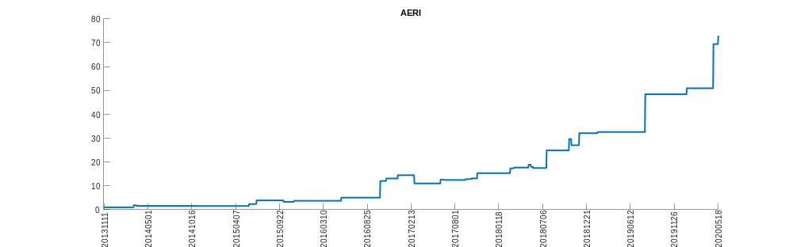
AGRO
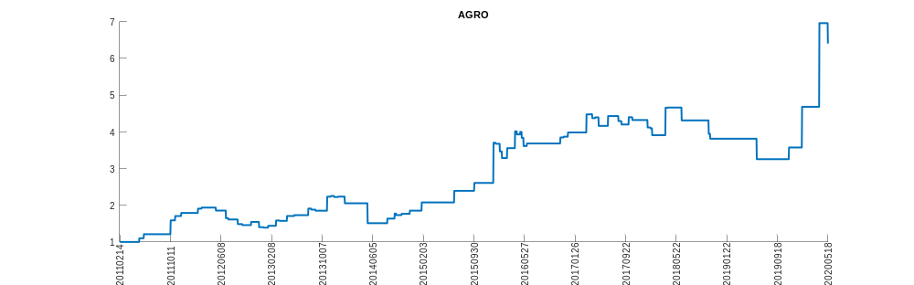
AGYS
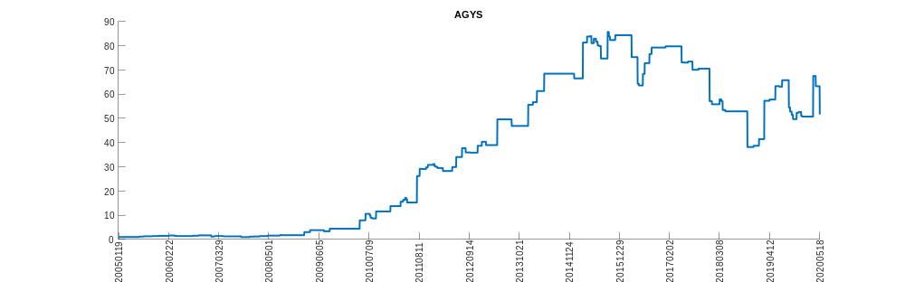
AIRR
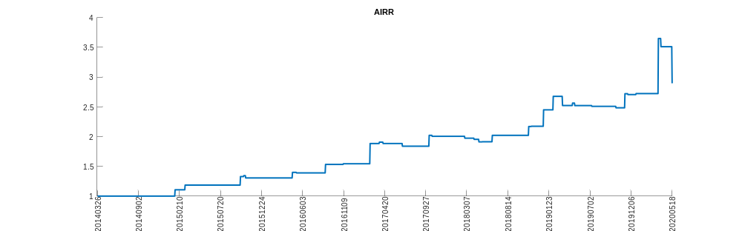
ALDW
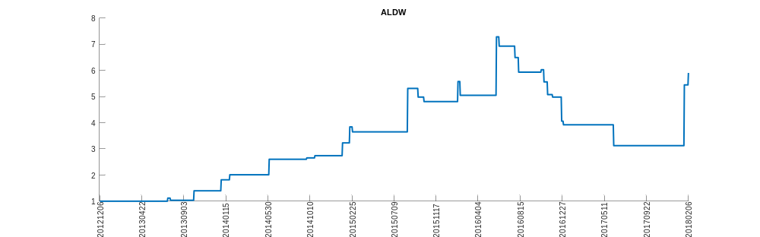
ALEX
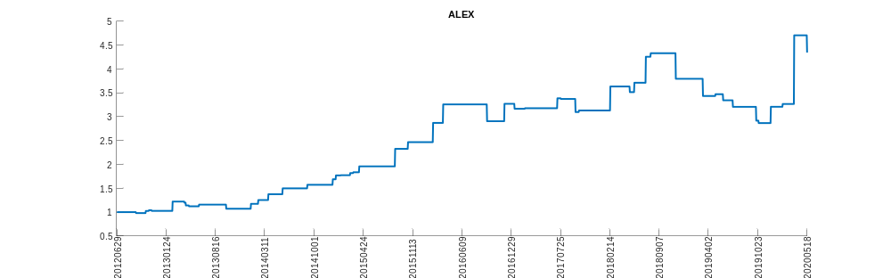
ANTH
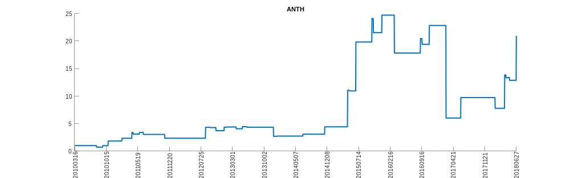
AQXP
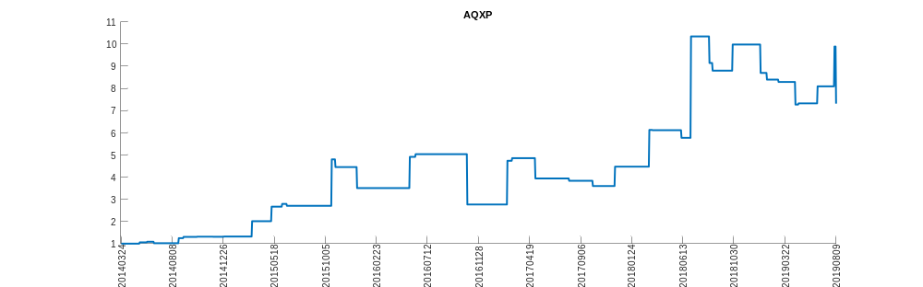
ATHM
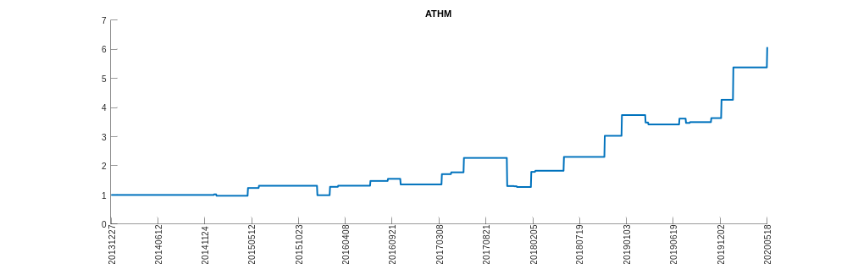
BBLU
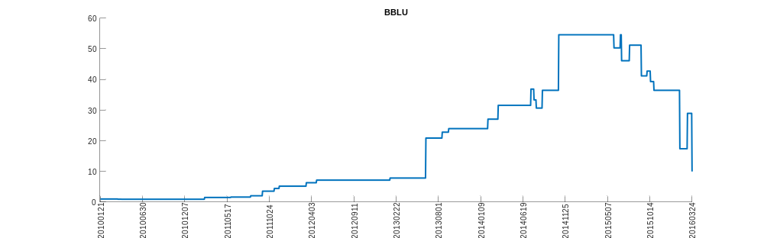
BBT_P_F
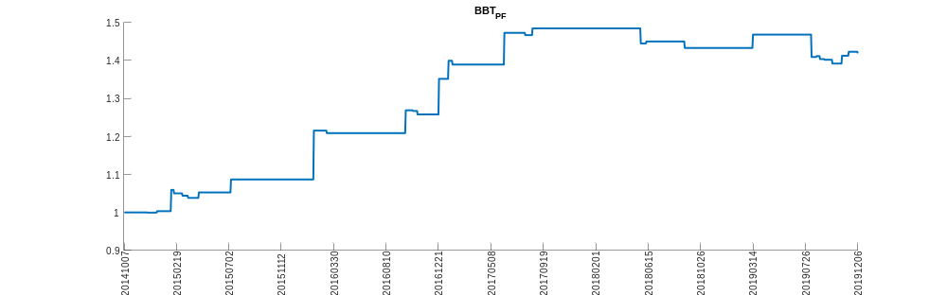
BERY
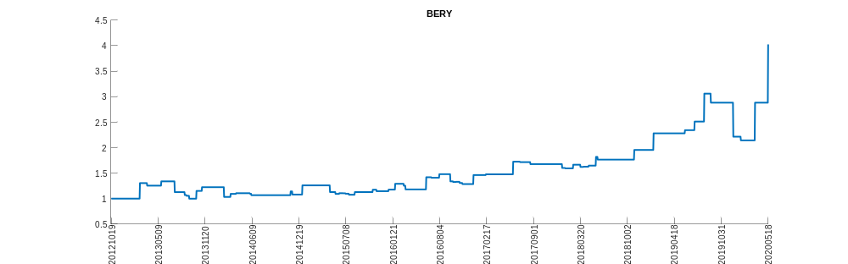
BSIG
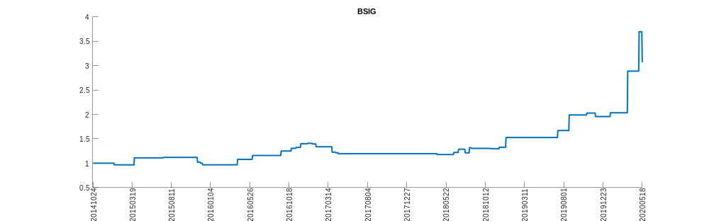
CELP
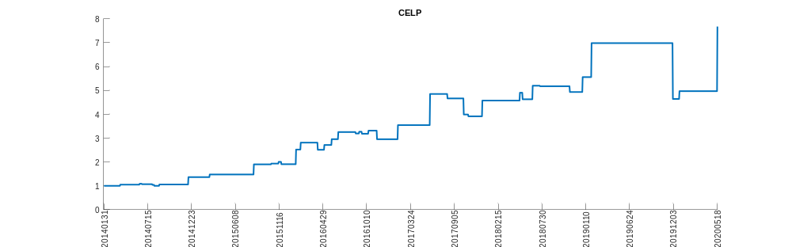
CFMS
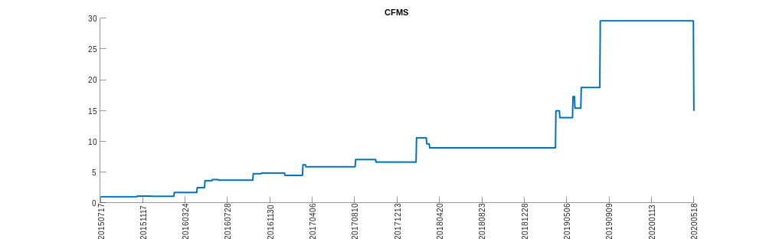
CHEKW
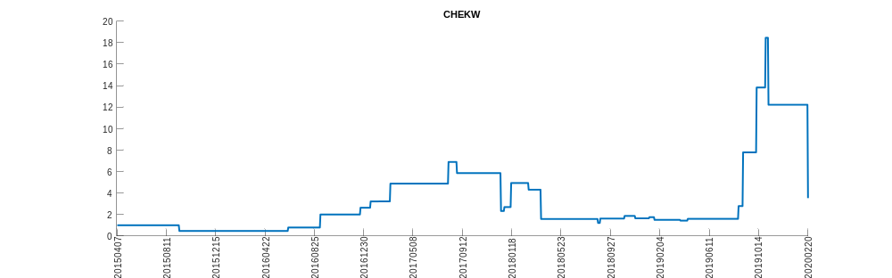
COMM
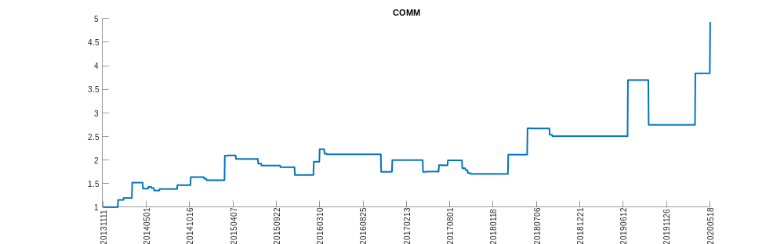
DIRT
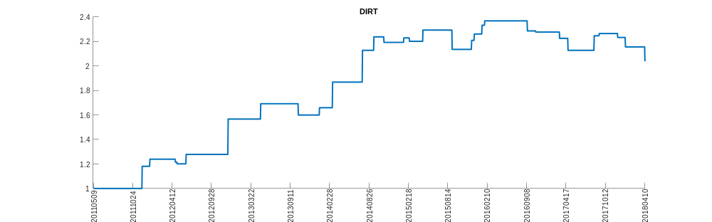
DKL
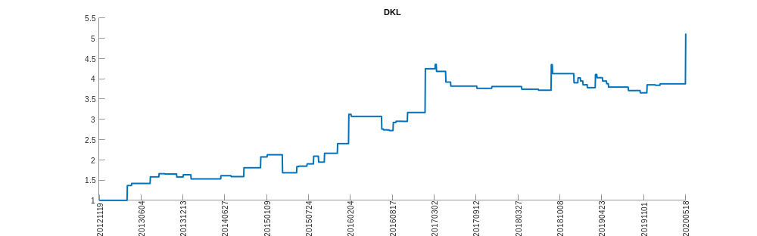
DTUL
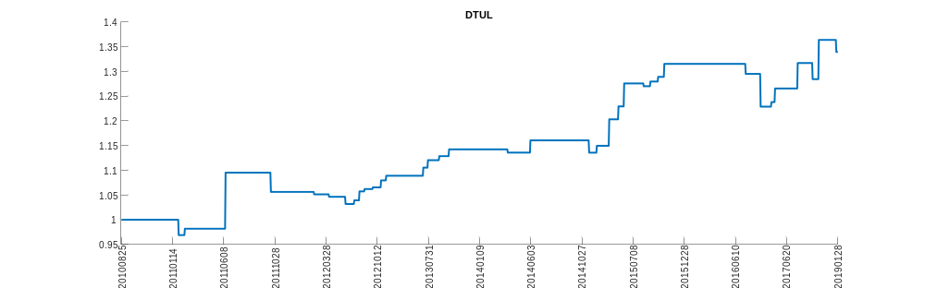
EELV
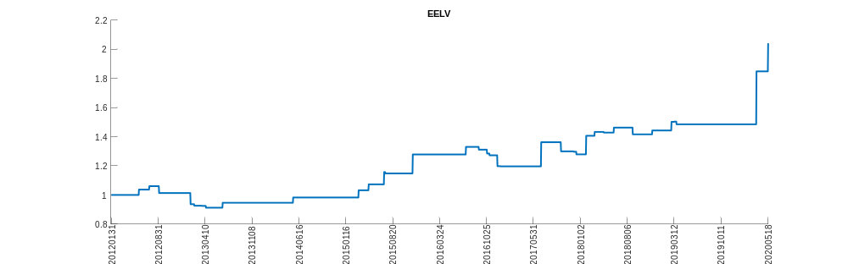
EPOL
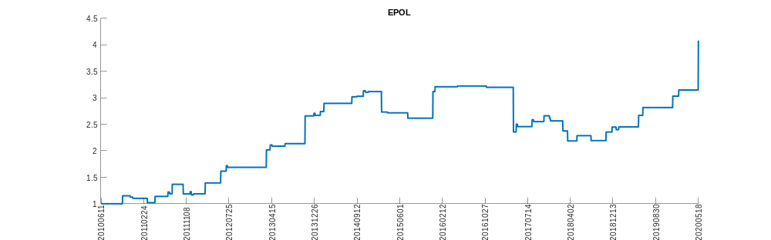
EROS
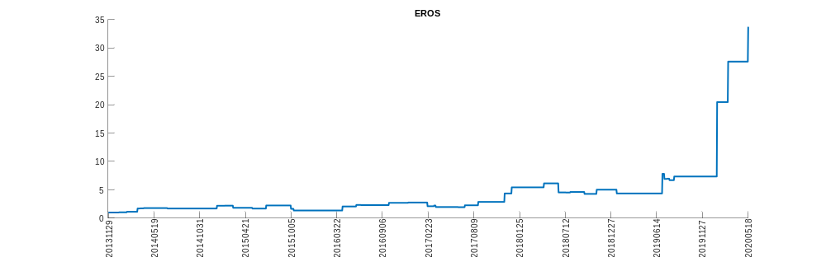
ERUS
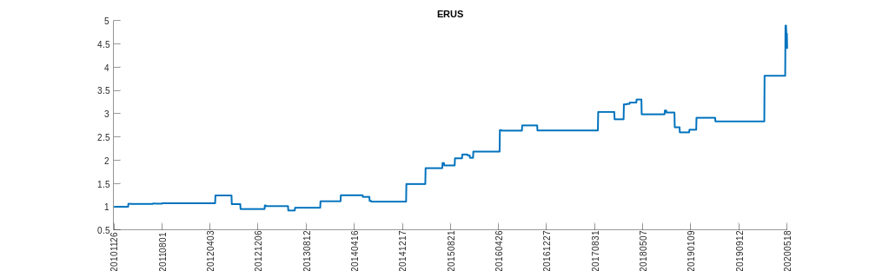
FFWM
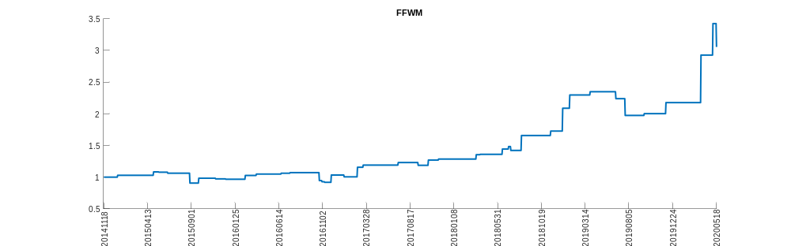
FIT
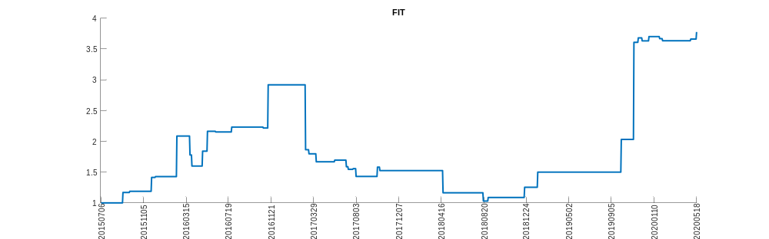
FOIL
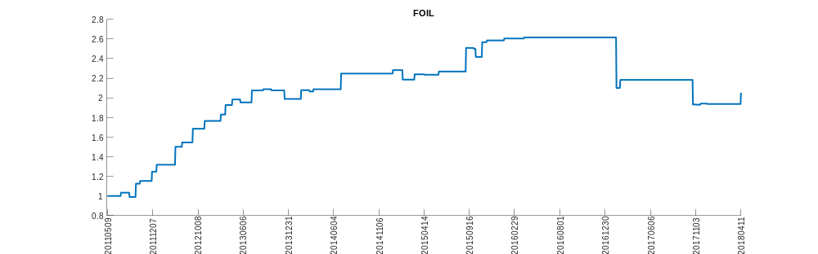
FTD
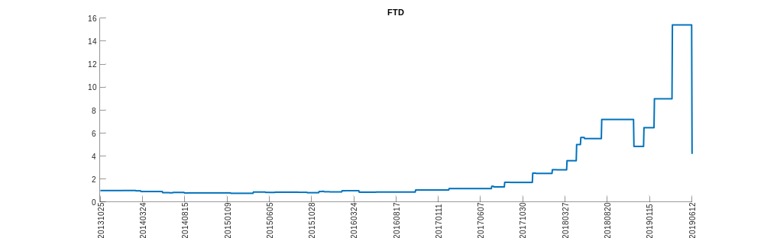
FTDCQ
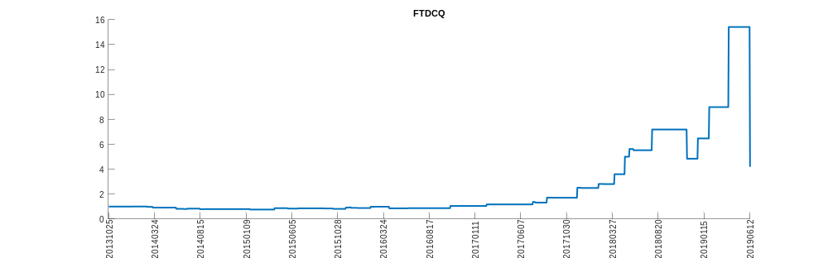
FTLS
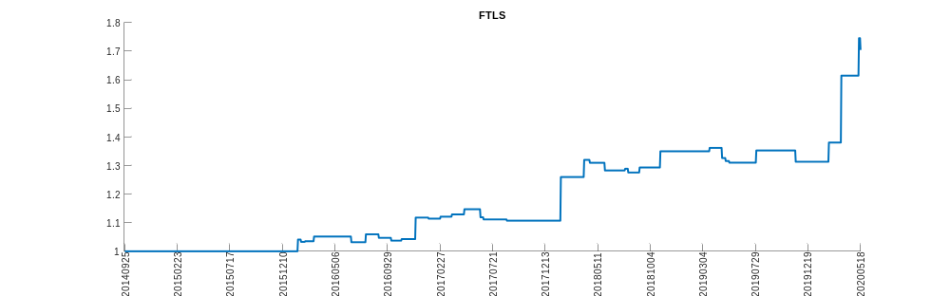
GLU_P_A
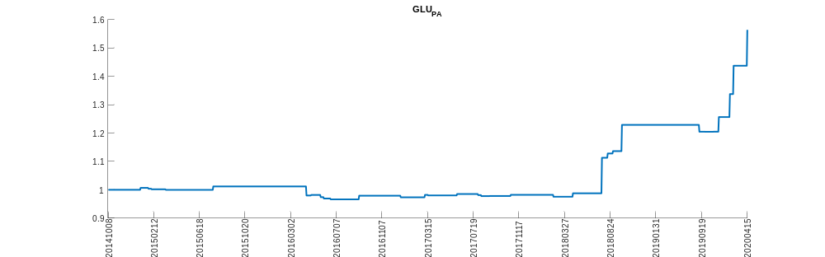
GM
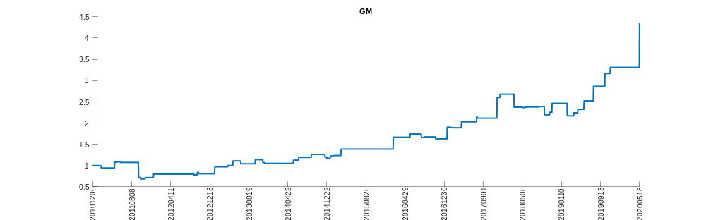
GSBD
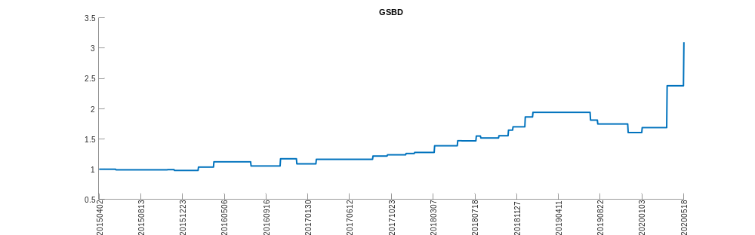
HUBS
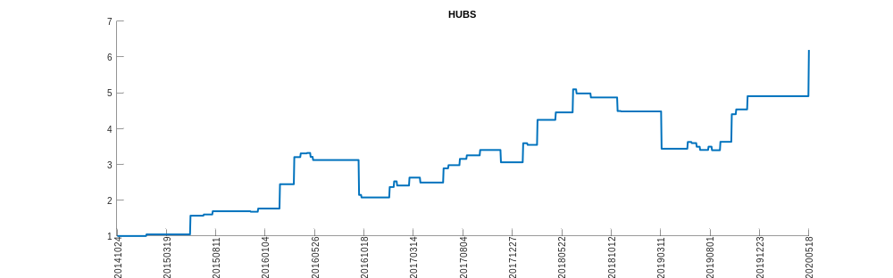
IDCC
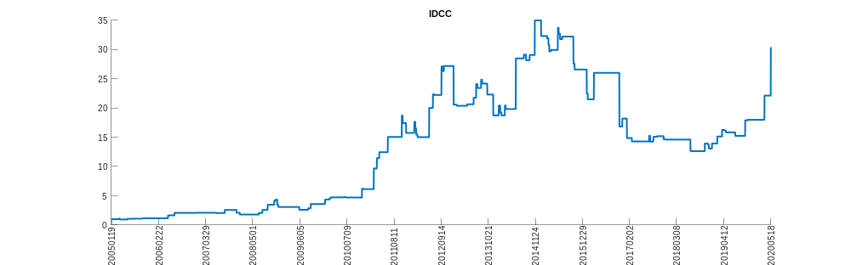
IMUX
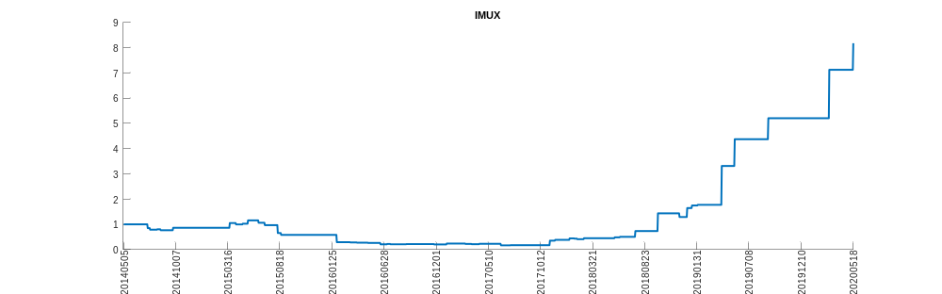
IRDMZ
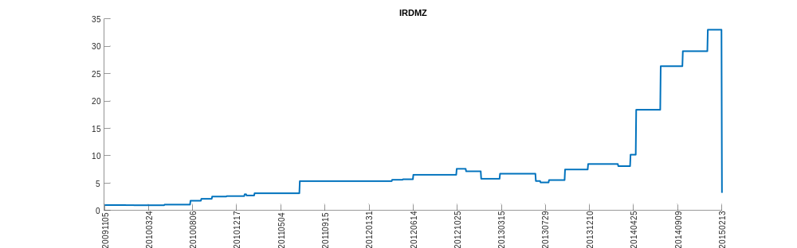
ISHG
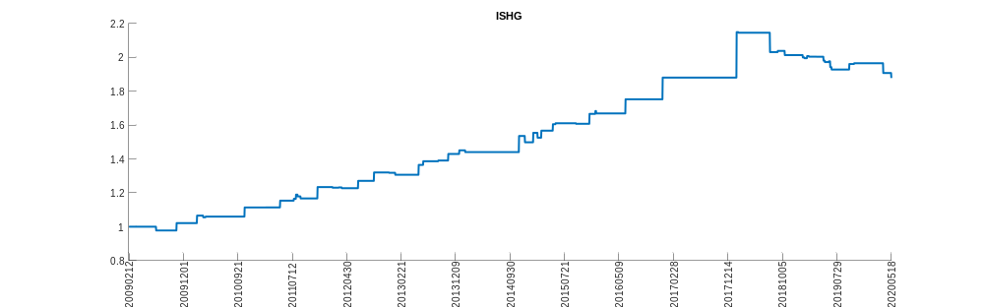
JBHT
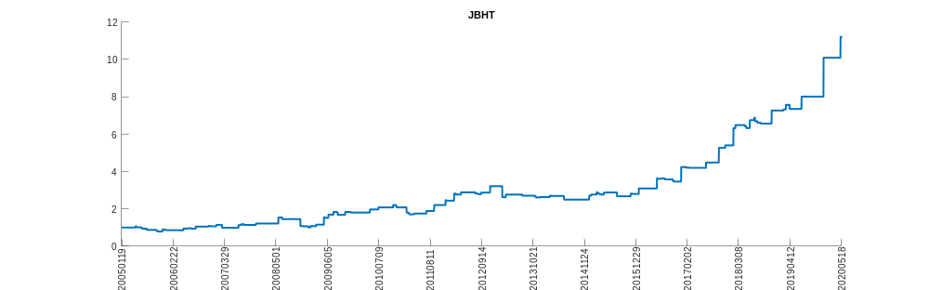
KMDA
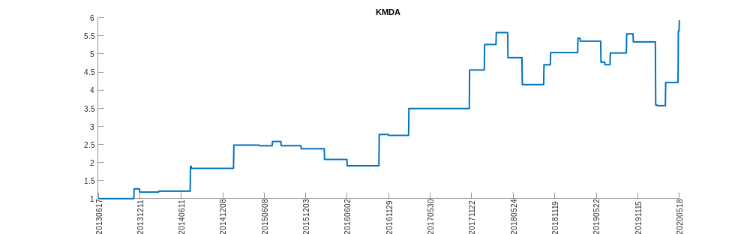
KODK
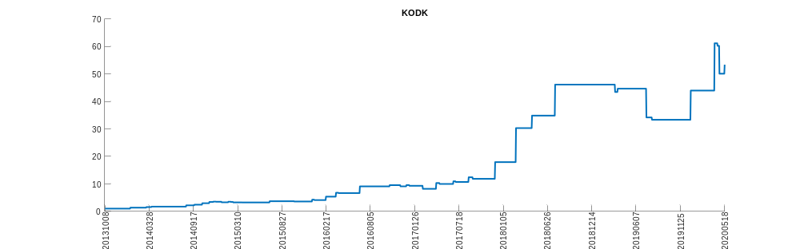
KORU
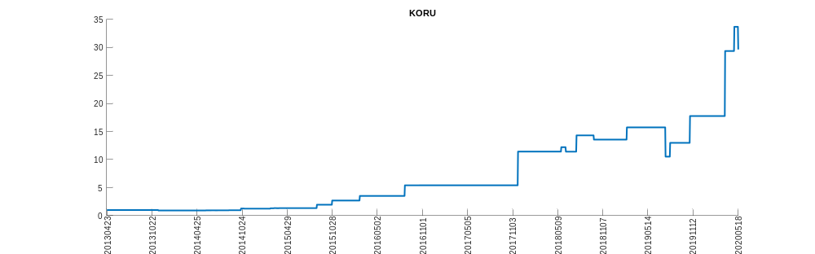
LQDH
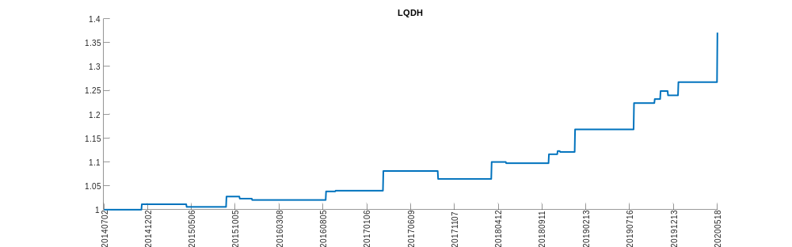
MLPC
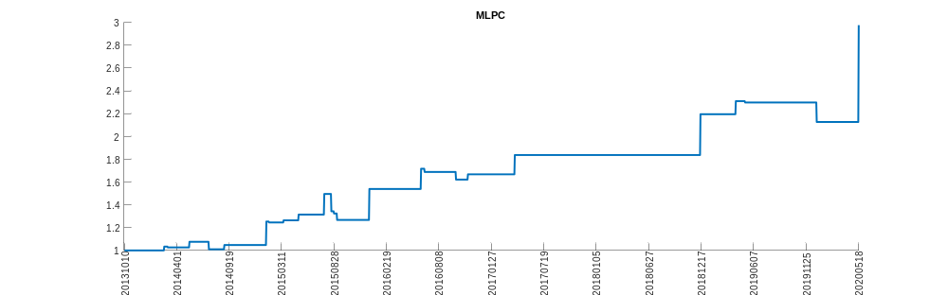
NKA
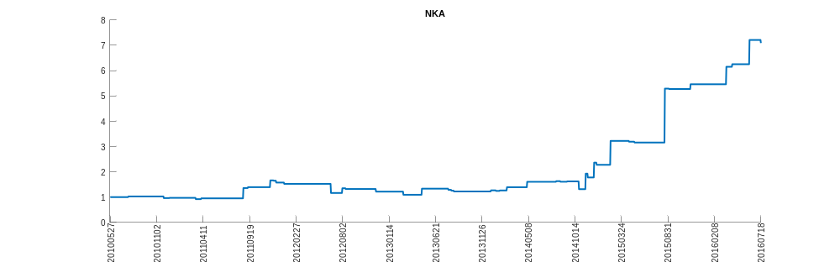
NM
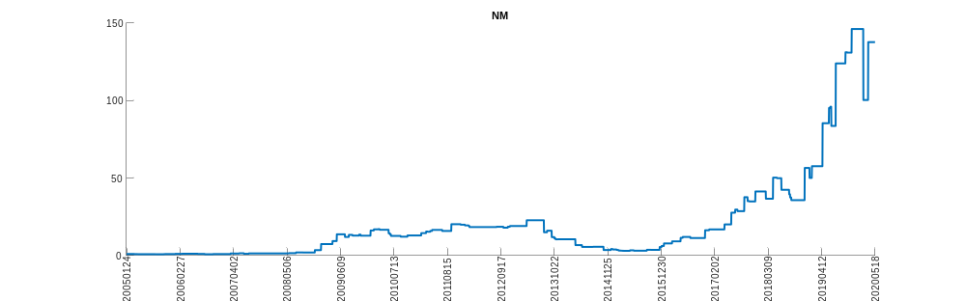
OWW
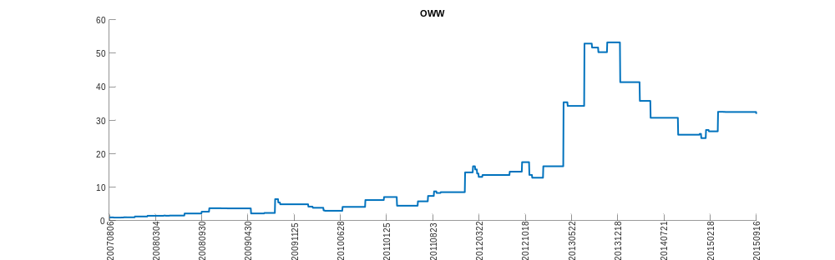
PCOM
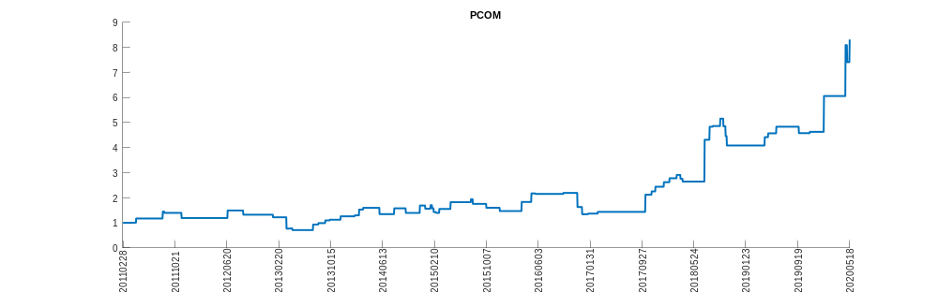
PETM
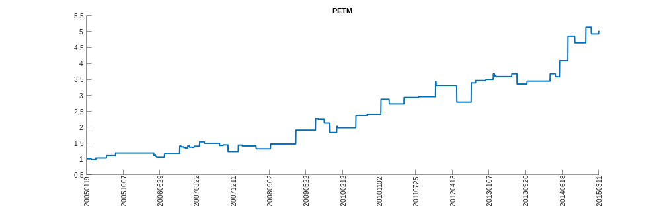
PRTY
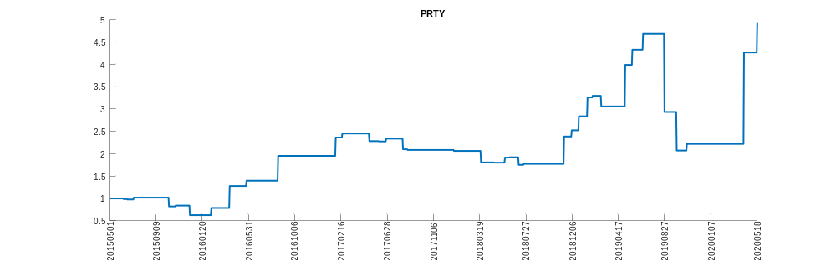
QEMM
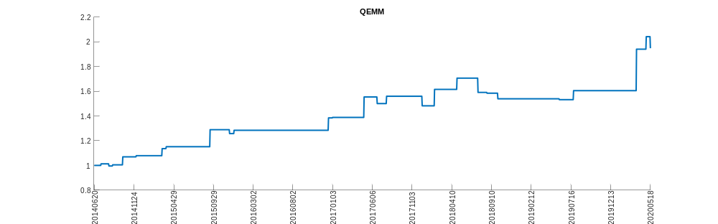
QUOT
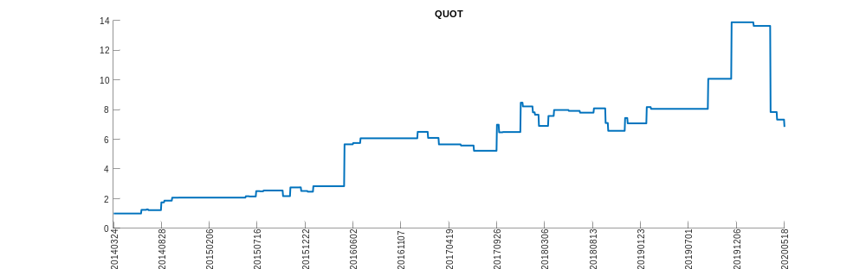
RBL
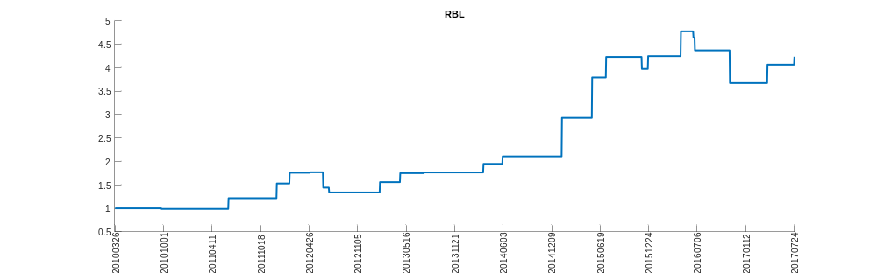
RESN
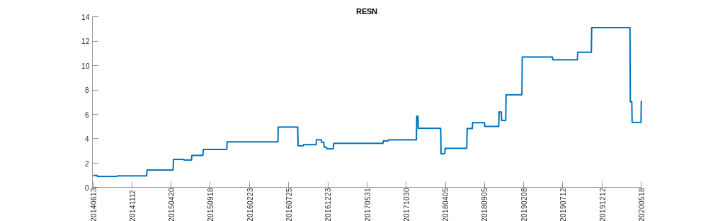
RUBI
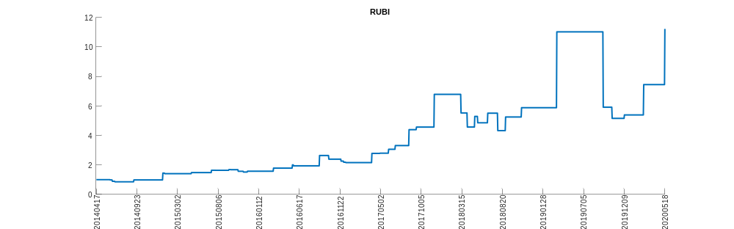
SPWH
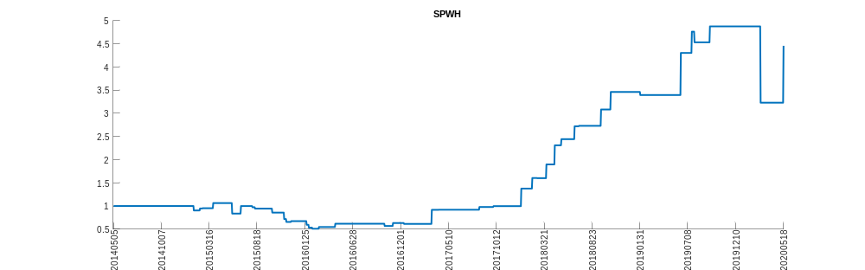
SRC
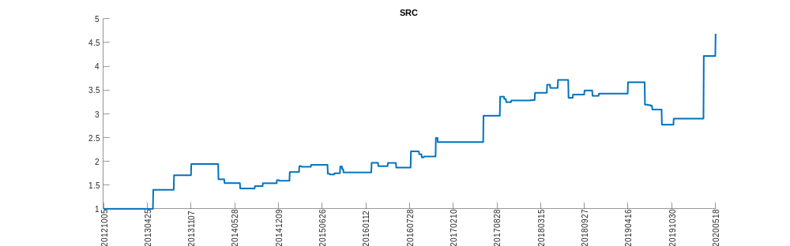
SRLN
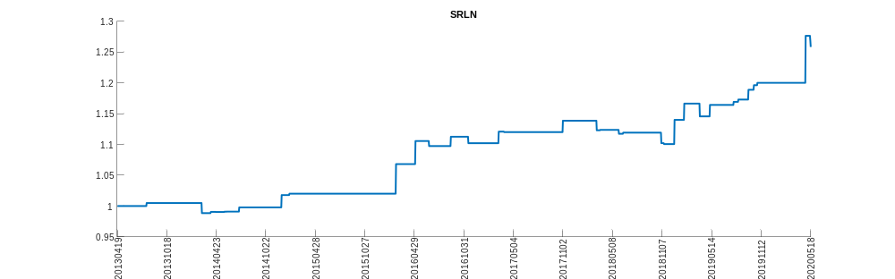
STPP
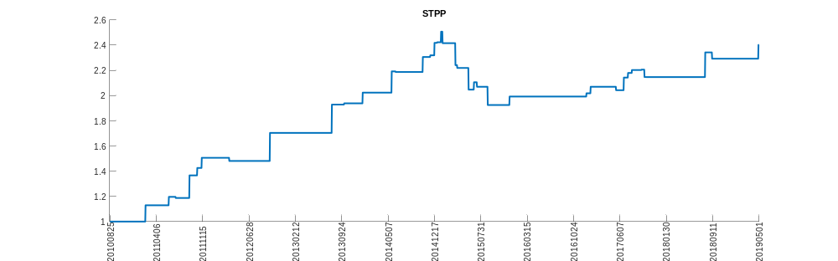
TECL
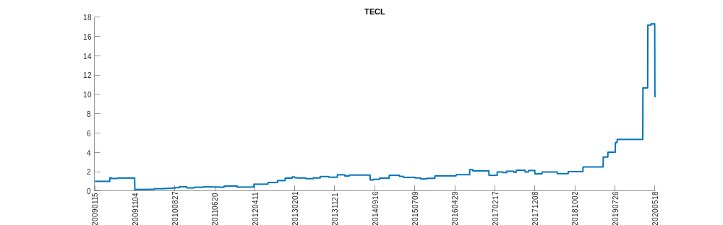
TFM
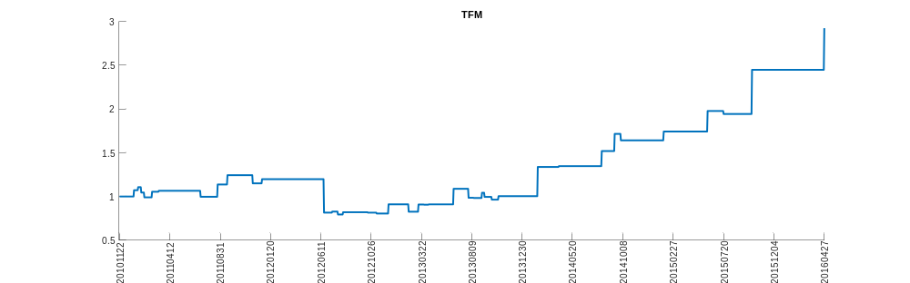
THOR_
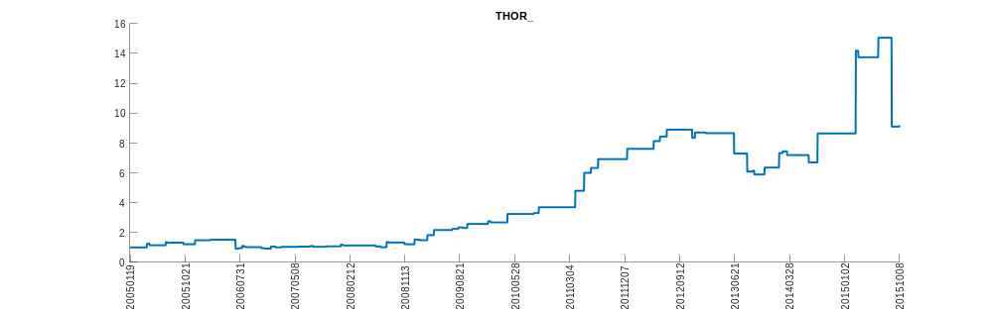
TOO_P_B
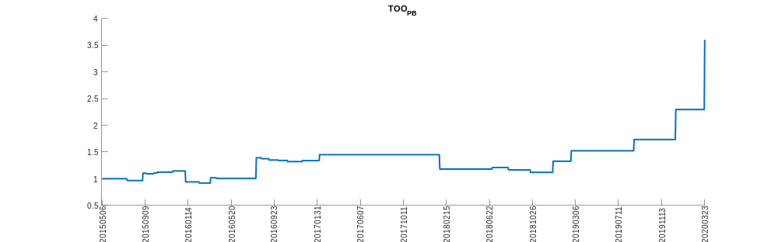
TWOU
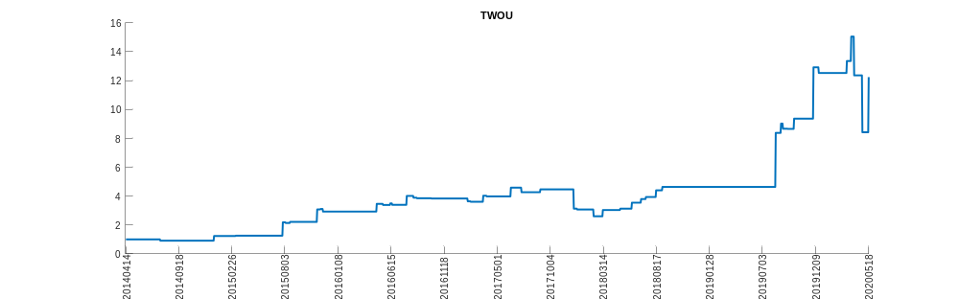
VNM
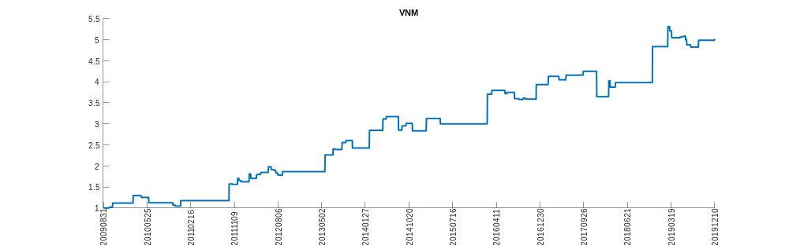
W
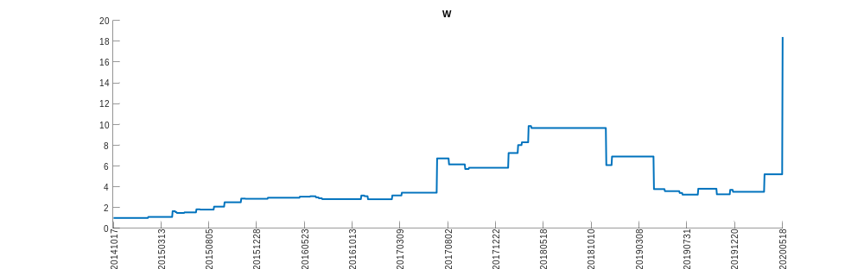
WBIA
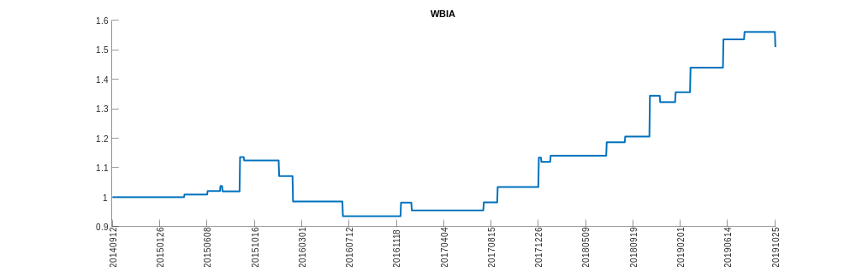
WBIB
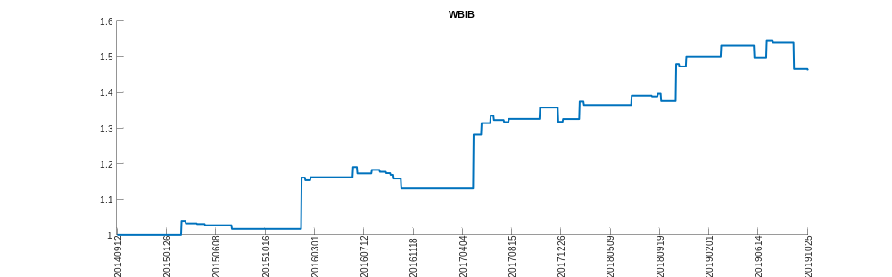
WBIL
